
ALL ABOUT MY NEW SETTING
LITTLE ACORNS PRESCHOOL

- Where We Are

- Meet Our Team
- A typical session at Little Acorns
- Activities We Do
- Useful Information

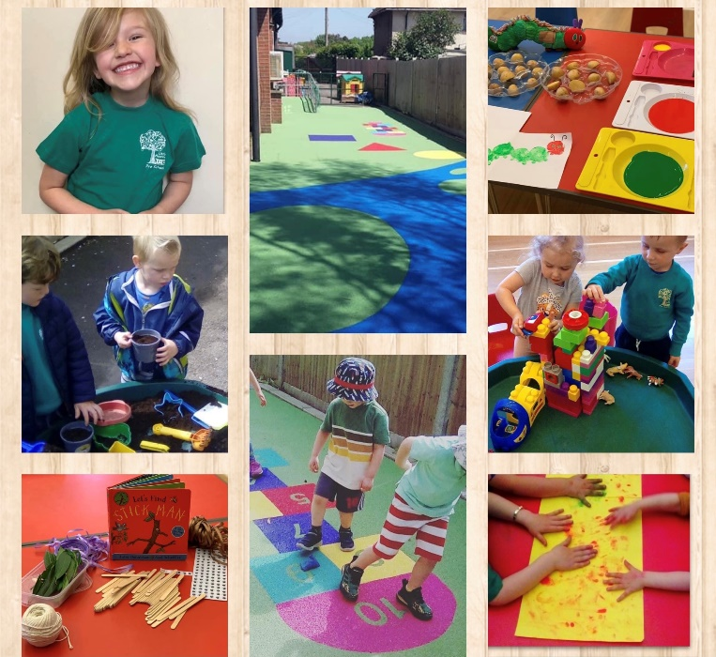

Where We Are
We can’t wait to welcome you to Little Acorns.
This is our Hall – Tatsfield Village Hall
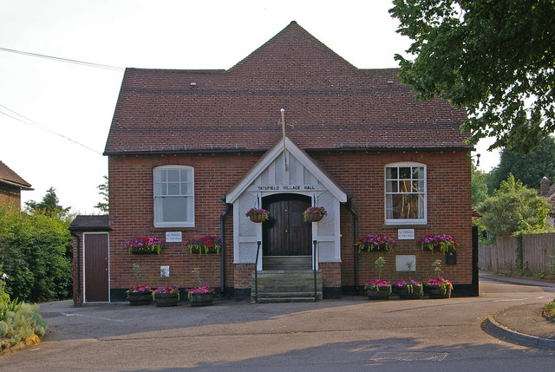
……..and this is inside before Little Acorns has got all of our toys and equipment out!
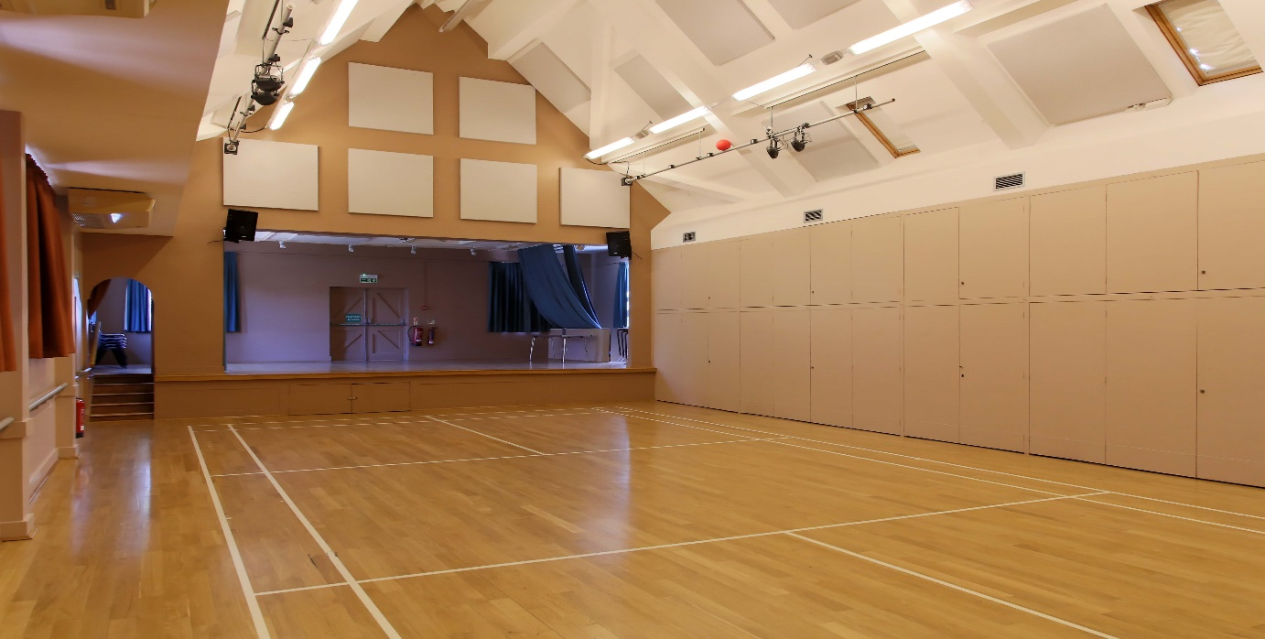
Imagine how many toys we can get in there!

We also have a lovely soft floor Outdoor Play Area ready for you to explore.

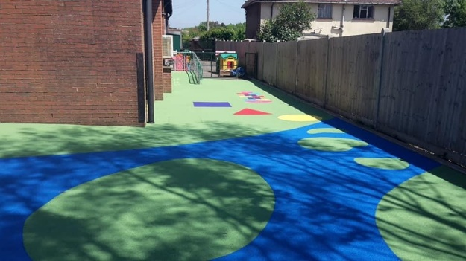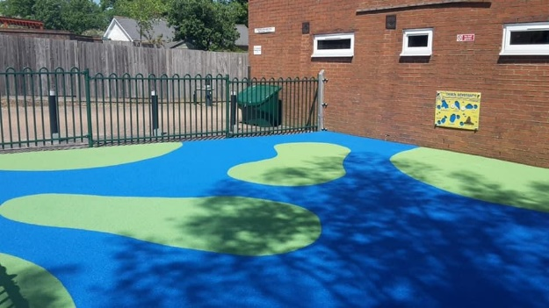
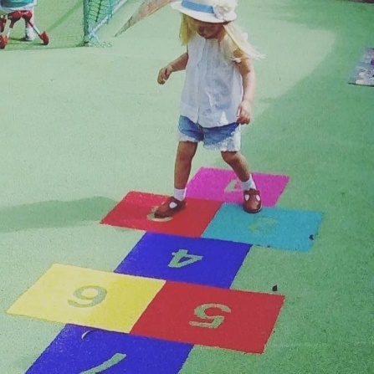

At Little Acorns we make ensure the children spend time
exploring & learning through play in a fun & safe environment.
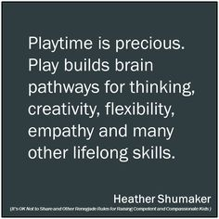
Our philosophy is "exploring & learning through play in a fun & safe environment". We take our philosophy very seriously and strive to ensure that our children learn new skills, feel safe, comfortable, and are free to play in each of our learning areas whilst in our care.

We are regulated by Ofsted and work closely with Surrey Early Years to ensure our practices are always in line with the Early Years Foundation Stage.

Meet Our Team
We have a lovely team at Little Acorns who will be looking after you.
Lisa   | Lisa is our setting manager and Safeguardig Lead (DSL) she started at Little Acorns in 2016. Lisa loves animals and learning about them and she enjoys cooking with our children. | Katie  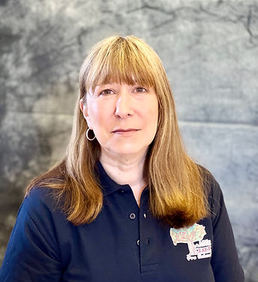 | Katie is our Setting Manager alongside Lisa, she also oversees our office and is chair of our committee. Katie has been with Little Acorns since 2010. She is DDSL and GDPO lead for the setting.
Jen  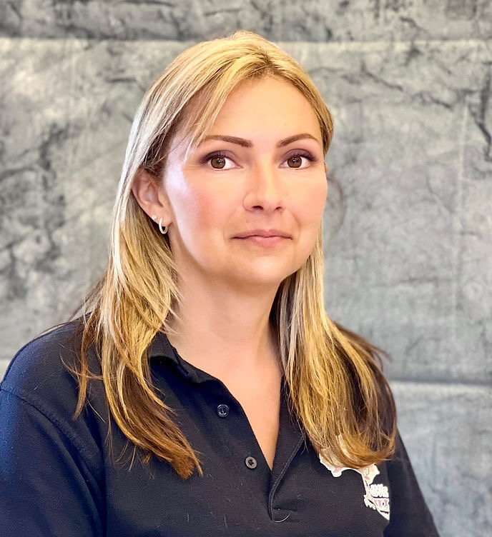 | Jen C is Level 3 qualified and has been at Little Acorns since 2017 she is also our Finance Officer. Jen likes lots of outside play. | Terri  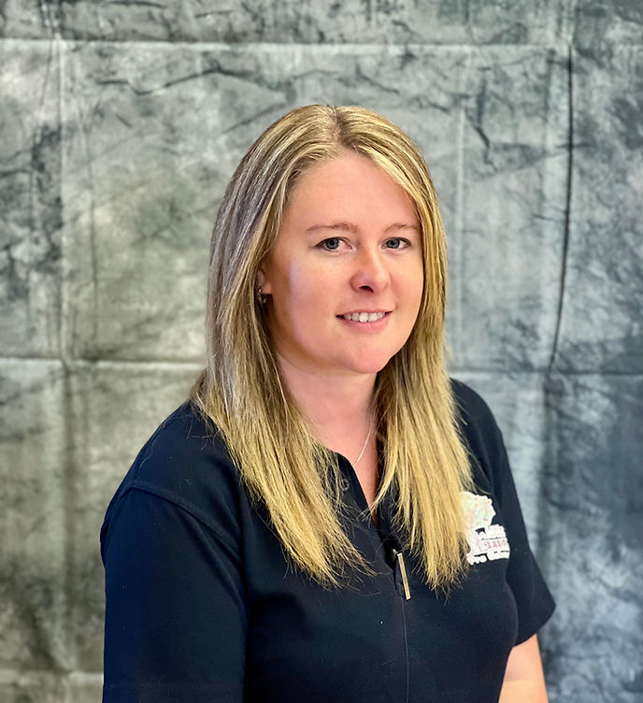 | Terri is level 3 qualified and our deputy SEND. She loves cooking (she’s a qualified chef!) and enjoys outside play with the children.
  Sam | Sam joined us in 2024 – she is currently training for her Level 2. Sam likes anything to do with art and craft and will put glitter on anything. | 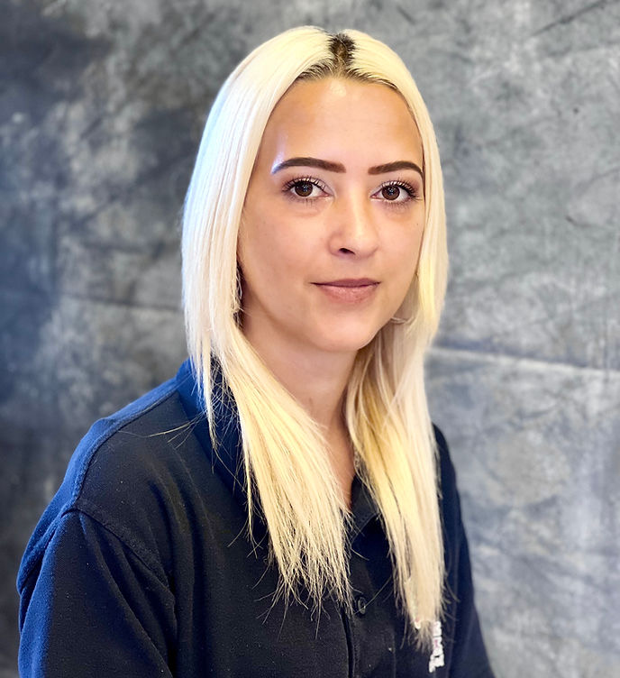  Dawn | Dawn has been with Little Acorns since 2015. She has 2 children. Dawn enjoys joining in with the children’s role play and singing.
Maxine  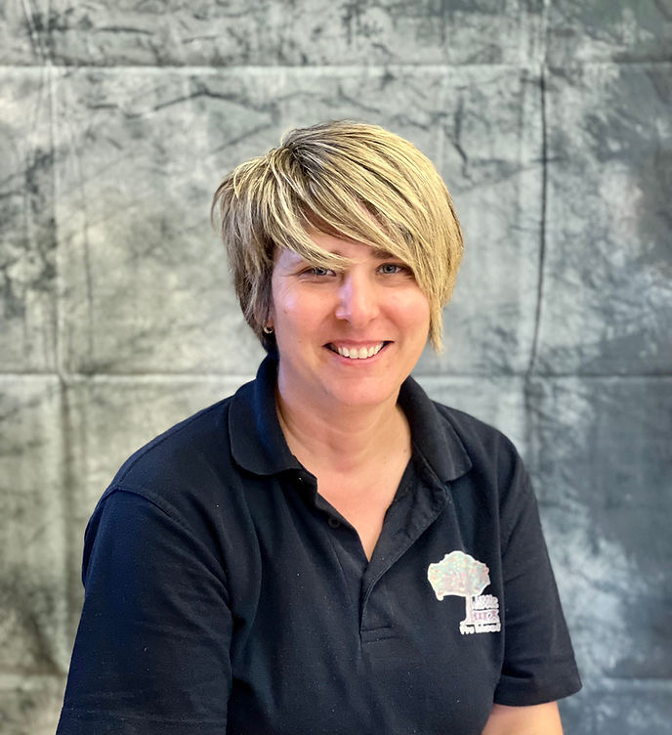 | Maxine joined our team in 2021 and holds a NVQ level 3 in childcare. Maxine is an expert at creative play and has lots of fun ideas! | 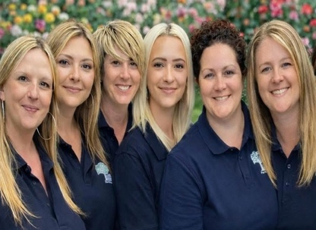 | All of our staff are fully trained in safeguarding, food hygiene and paediatric first aid.

A typical day at Little Acorns
Time | Activity
8:30 -9:00am | Children arrive 
9:00am | Free Play in the hall. 
09:30am | Free Play, Focus group learning and 1:1 Work
10:00am | Doors to our outside play area are opened for free flow play
10:15am | Snack Time starts 
11:35am | Outdoor Play finishes
11:45am | Tidy Up Time 
11:50am | Circle Time and Story & Song Time 
12:00pm | Morning children collected to go home  Afternoon only children arrive
12:00noon | Free Play
12:15pm | Wash hands and lunch
12:30pm | Free Play and Outdoor Play Area open 
2:55 - 3:20pm | Outdoor Play Area tidy & closed  Tidy up time & home time

*Please note;
This provides a basic time frame for a typical day - we do have various activities going on so the timetable is subject to change.
Our Monday morningds include our art club sessions, Wednesday mornings we have football club, Thursday afternoon hosts science club and Fridays are messy play! All included in the session fee.
Activities
We are always very busy! These are some of the great things you can do while with us.
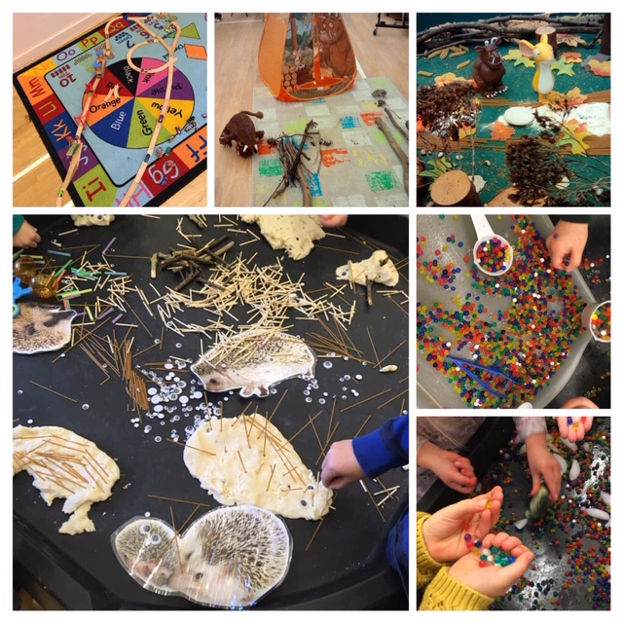 | 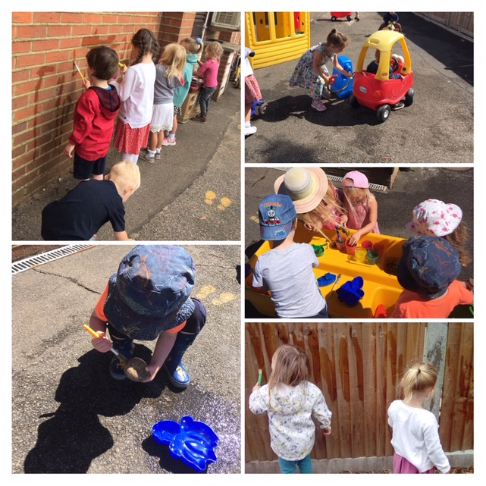
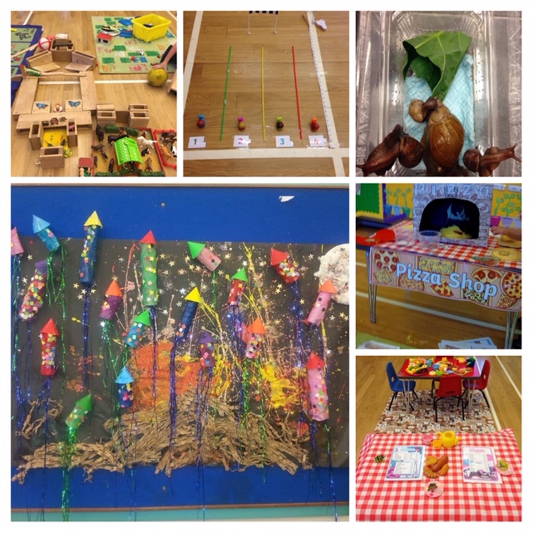 | 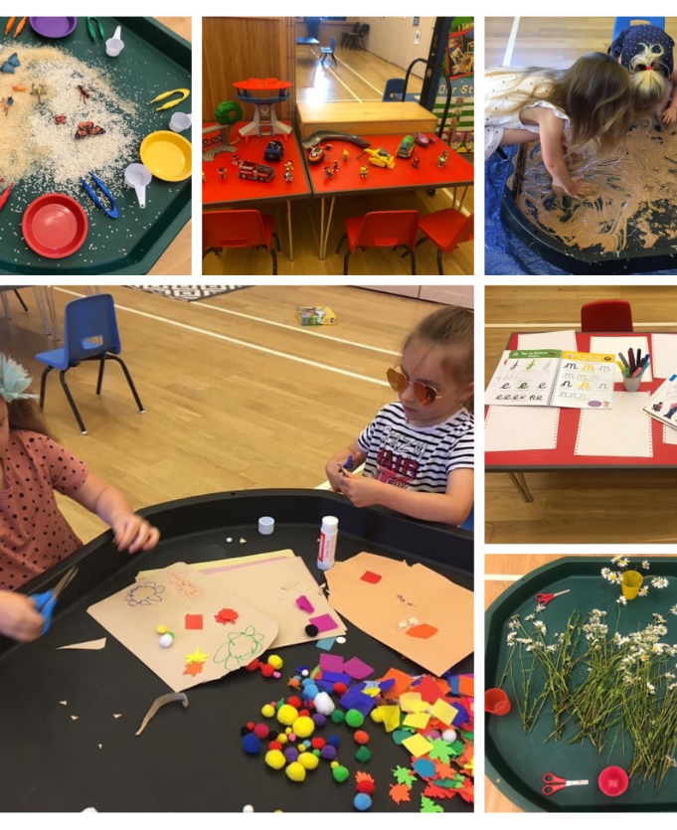

Useful Information
Opening Times
We are open term time only for the following sessions:
Monday | Tuesday | Wednesday | Thursday | Friday
8:30 – 12 | 8:30 – 12 | 8:30 – 12 | 8:30 - 12 | 8:30 - 12
12-1 lunch club | 12-1 lunch club | 12 – 1 lunch club | 12 – 1 lunch club | 12-1 lunch club
12 – 3:20 | 12- 3:20 | 12 – 3:20 | 12 – 3:20
Art club am |  | Football Club am | Science Club pm | Cooking/Messy
You can combine any mix of sessions, subject to availability.
Fees
Session | 2 year old | 3+ year old
Morning session | £24.50 | £21.00
Additional Lunch club (12:00-1:00) | £7.00 | £6.00
Afternoon session | £22.50 | £20.00
We accept all forms of government funding and tax free childcare payments.
Consumables charge
A £1.50 per day consumables charge is invoiced every half term to parents. This is voluntary and covers consumables used and morning snack at preschool. If you do not wish to pay this charge, please let us know.
Online Learning Journal
We use Tapestry for all of our children to record their learning journey with us. Tapestry is an online diary which you share with Little Acorns. We can each post updates and photos of your child to your private, secure account and is a great way of sharing your child’s progress, development and WOW moments.
Facebook
Little Acorns has a closed Facebook group page for parents and carers which you can join once your child has started at our setting. It is updated regularly with notes and dates about Little Acorns and information of any upcoming events.
Visits
Visits to our setting are to be prebooked. If you wish to book a visit, please contact office@littleacornstatsfield.co.uk and we will be happy to help you. We hope this leaflet gives some idea of what Little Acorns can offer your child and what we do. Please also look at our website www.littleacornstatsfield.co.uk which has more information for you together with our policies and procedures.
We look forward to meeting you!
Please contact our Office Manager for any further information –office@littleacornstatsfield.co.uk

